# Team Name Note Determined

# Meeting Minutes

January 22, 2014

1. **Call to order**

Regular meeting of the MET CS 473 C1 Software Engineering at 8:00 PM on January 22, 2014 at BU.

1. **Roll call**

The following persons were present:

* **Team 1** Jackie ALdama, Evan Panahi, Julia Cheong, Swapnil Shinde, Rishee Basdeo, mike demers
* **Team 2**Chris Theberge, keith hale, charyn eagan, karen palmer, Dan Anderson, Justin Therrien
* **Team 3** Lauren Smith, raedeb Sanford, wail alghanmi, Dan Cusher, Shuran Hang, Nik Yusof

1. **Approval of minutes from last meeting**

[Secretary Name] read the minutes from the last meeting. The minutes were approved as read. Please review and update as needed

1. **Discussion Point 1**
2. Communication
3. Source Control
4. Database server (MySQL)
5. Development Environment (Eclipse)
6. Sunday Meeting 9:00 PM

**Users:**

1. *Service Providers
   1. Food Kitchen
   2. Homeless Shelters
2. *Charity
   1. Individual
   2. Corporate
   3. State rehabilitation programs

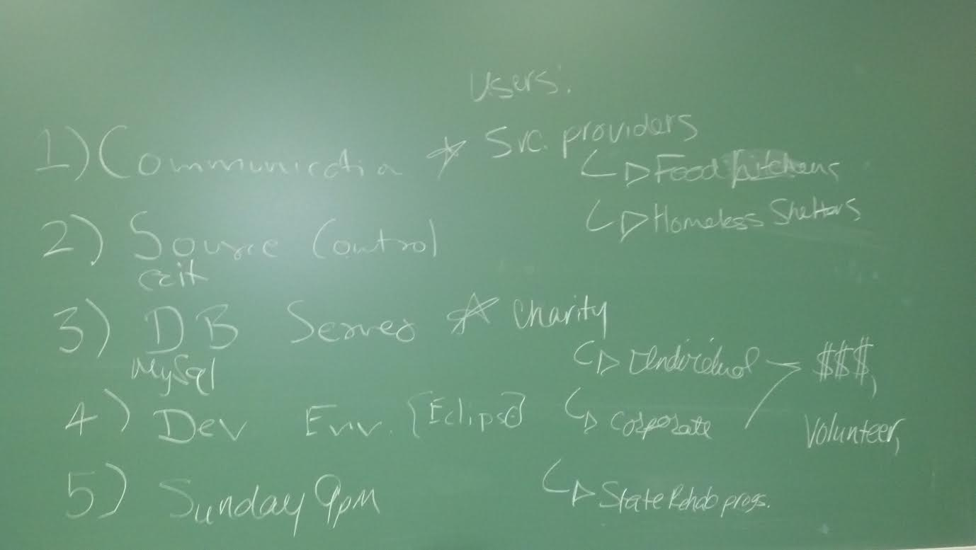

1. **Discussion Point 2:**

**General Architecture:**

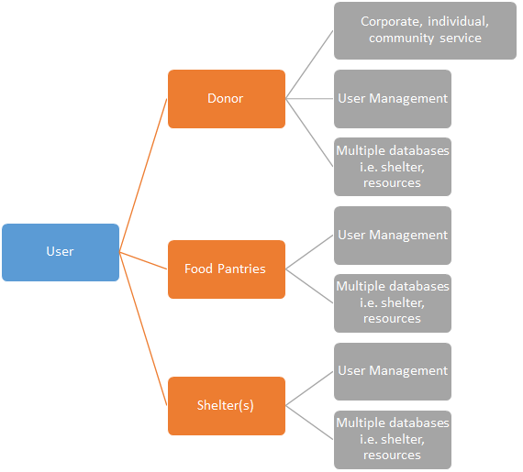

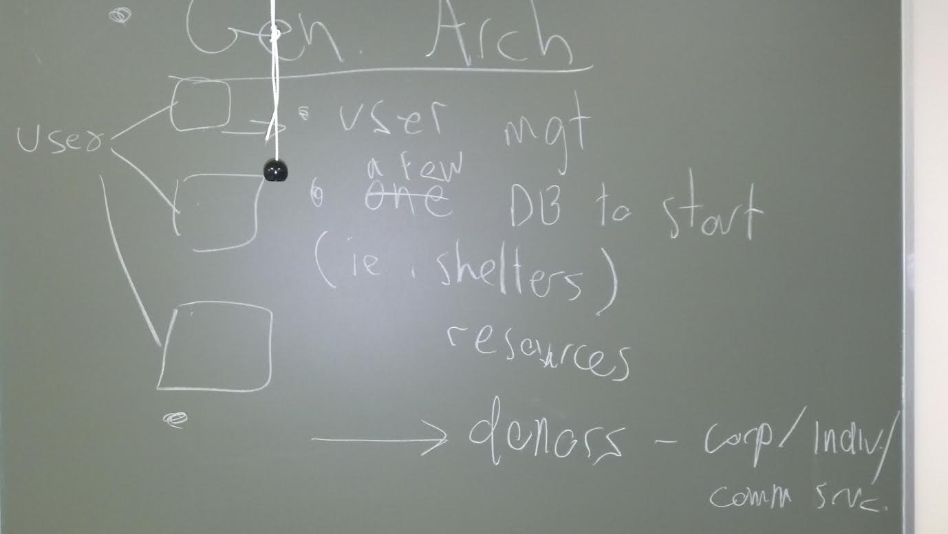

1. **Open issues/Tasks**
2. Create Group Email Accounts – Karen Palmer
3. We need to finalize the three parts of the project
4. Donor(s)
5. Food Pantries
6. Shelters
7. Review & provide additional input to meeting minutes
8. Review and provide recommendations for Team Project name due 1/25/14
9. Review agenda for Meeting provide input prior to meeting
10. Review and add requirements to the list prior to the call, we will be reviewing and discussing requirements heavily on the Call
11. **Closed Tasks**
12. Create common repository My Drive Google Drive
13. Create Organizational Chart
14. The teams have been selected: (please let me know if there are any concerns)

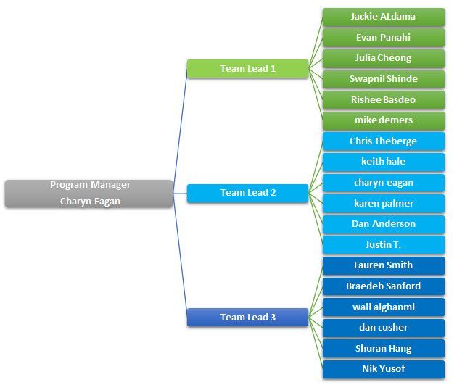

1. **Figure 1 Organizational Chart**